PATTERN MATCHING WITH REGULAR EXPRESSIONS AND PARSING STRUCTURED DATA – LAB 05

5C 5080 – SOFTWARE CONSTRUCTION

WIAJYAWARDHANA W.A.H.A.

2019/E/166

SEMESTER 05

11 OCTOBER 2022

QUESTION 01

01.

//import necessary packages  
import java.util.Scanner;  
import java.util.regex.Matcher;  
import java.util.regex.Pattern;  
public class Regularexp {  
 public static void main(String[] args){  
 Scanner scanner = new Scanner(System.*in*);  
 while (true) {  
 //Read Regex from user  
 System.*out*.println("Enter the regex : ");  
 String readRegex = scanner.next();  
 //Create the pattern  
 String patternString = "A";  
 Pattern pattern = Pattern.*compile*(patternString,Pattern.*CASE_INSENSITIVE*);  
 //Read the input string to check the match  
 Matcher matcher = pattern.matcher(readRegex);  
//Create a matcher  
 boolean found = false;  
 int j =0;  
 while (matcher.find()) {  
 System.*out*.println("I found the text "+ patternString + " starting at index "+ matcher.start()+ " and ending at index "+matcher.end()+".");  
  
//Print as: I found the text "j" starting at index 0 and ending at index 1.  
 found = true;  
 }  
 if(!found){  
 System.*out*.println("Could not found.");  
//Print  
 }  
 }  
 }  
}

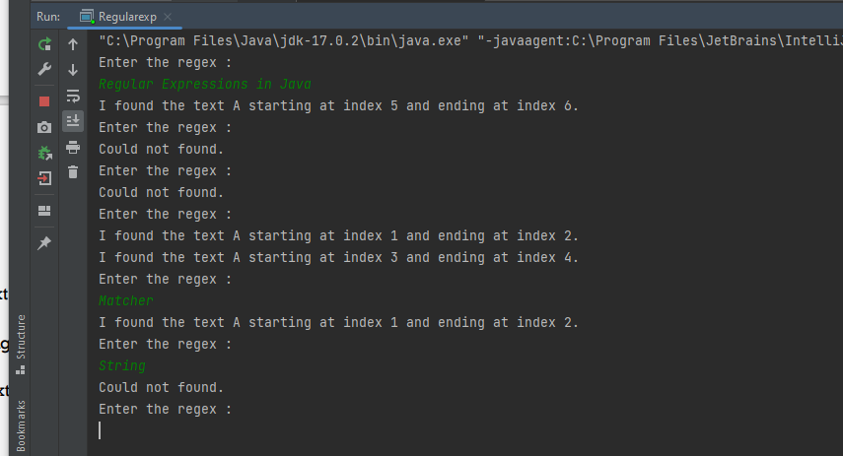

02.

